IT1604: City-Leased Fiber Network
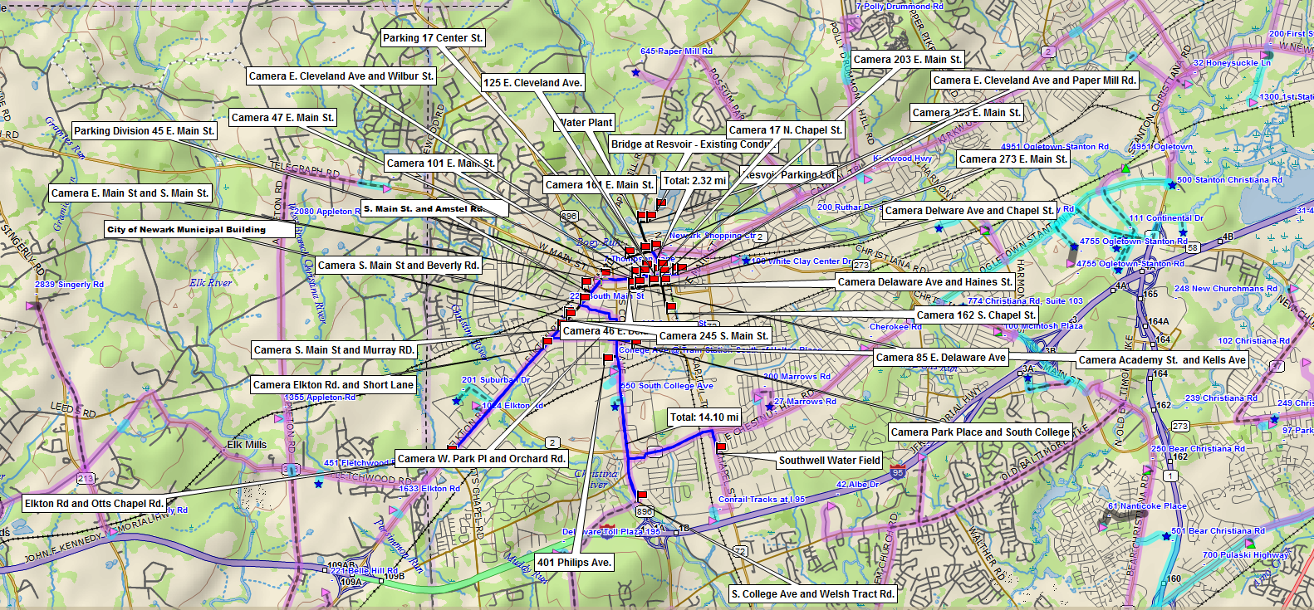
Leased Fiber
Available Un-Leased Fiber
Building or Camera Asset

