Cleveland Avenue to Paper Mill Road
Off-Road Pedestrian/Bike Trail

The objective of this investigation is to improve safety of bike and pedestrian travel by keeping bikers and pedestrians off of Cleveland Ave. The current length of this stretch of Cleveland Avenue is 0.60 miles.

Proposed Alignment Map:

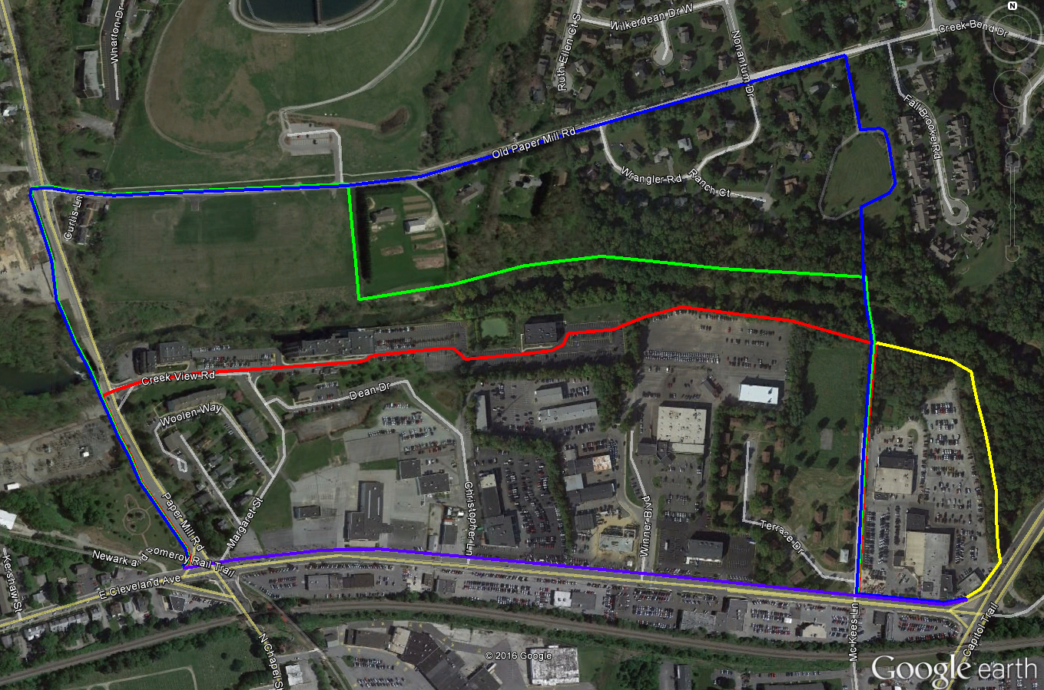

Alignment 1

- Alignment 1 is the red path on the map and has a length of approximately 1.00 mile.
- Alignment 1 would run down Cleveland Avenue on a widened (as possible) sidewalk to McKees Lane where it would turn north to the White Clay Creek. From here it would turn West and travel along the north side of the McKees Solar Park and Porter Nissan, outside of the existing fenced areas. It would then enter the Mill at White Clay parking lot and travel out to Paper Mill Road using the existing drive aisles. Once the path reached Paper Mill Road it would require a new signal at the intersection of Creekview Road to safely get people to the existing paths on the west side of Paper Mill Road.
- A boardwalk type elevated path may be needed behind Porter Nissan due to the close proximity to the existing fence line of what we believe may be wetlands.
- The proposed traffic signal at the intersection of Paper Mill Road and Creekview Road would provide additional benefits to the primary function of getting trail users safely across Paper Mill Road. It will allow for a less painful conversion of Margaret Street to one way, alleviating congestion at the Cleveland intersection with Paper Mill Road. It will also allow for left turns out of Creekview Road. Left turns into Creekview Road will likely require a dedicated left turn lane which will not be possible without widening the Paper Mill Road bridge.
- The City will have to, at a minimum, secure a public access easement and likely a maintenance cost share agreement for the portions of the path that are located on private property (Mill at White Clay).
- Identified upsides of this alignment: it is the least out of the way; it requires the least new construction; it will provide easy access to the residents of Alder Creek; it will not require the expense of another pedestrian bridge over the White Clay Creek; and it would have synergy with the desire to eliminate exiting traffic from Margaret Street into the Cleveland and Paper Mill Road intersection.
- Identified downsides of this alignment: it will require the cooperation of several private landowners; it may require construction of an elevated portion of trail if there is not enough room between Porter Nissan and adjacent wetlands; portions of the path will fall within drive aisles of the Mill at White Clay; it will require the construction of a traffic signal; and it will not provide a connection to the Reservoir, Redd Park, and the proposed Preston’s Playground and Old Paper Mill Park.

Properties affected by Alignment 1:
- Timothy’s of Newark (Mill at White Clay)
- Cash Connect (Mill at White Clay)
- Applied Control Engineering (Mill at White Clay)
- McKees Park
- Porter Nissan
- Porter Chevrolet - Optional

Alignment 2

- Alignment 2 is the blue path on the map and has a length of approximately 1.47 miles.
- The path would run down Cleveland Avenue on a widened (as possible) sidewalk to McKees Lane where it would turn north, head down McKees Lane, cross the White Clay Creek at or adjacent to the current location of “White Clay Creek Dam 3”, travel through Karpinski Park and out to Old Paper Mill Road (ADT < 500 vehicles per day). From there it would follow Old Paper Mill Road west to the existing crosswalk at the intersection of Old Paper Mill Road and Paper Mill Road and onto the off road pedestrian trail in Curtis Park. There is already a project underway to provide a pedestrian bridge parallel to the existing Paper Mill Road bridge that will connect the Curtis Park trail south to the Pomeroy Trail and Cleveland Avenue.
- Bike facilities will need to be added to Old Paper Mill Rd; upon inspection of the road, bike lanes can be easily added closer to Karpinski Park however the road will need to be widened along the Reservoir property to Paper Mill Road as it is too narrow at the moment for a bike lane. Alternately, an off road path can be constructed on the Reservoir or Old Paper Mill Park properties.
- Identified upsides of this alignment: it will not result in taking on maintenance responsibility for facilities on private property, or require the cooperation of any private property owners aside from possible widening of the sidewalk in front of Porter Chevrolet; It will provide easy access to the residents of Alder Creek, and a more convenient connection between Cleveland Avenue and points east to the off road paths at the Reservoir, Redd Park, and the proposed Preston’s Playground and Old Paper Mill Park.
- Identified downsides of this alignment: it is slightly more out of the way when compared to Alignment 1; it will require an additional pedestrian bridge over the White Clay Creek; and it will likely require widening of Old Paper Mill Road or construction of a parallel multi-use path due to limited existing paving width along the Reservoir property.

Properties affected by Alignment 2:
- McKees Park
- Karpinski Park
- Old Paper Mill Rd
- Reservoir - Optional
- Old Paper Mill Road Park - Optional

Alignment 3

- Alignment 3 is the green path on the map and has a length of approximately 1.36 miles.
- This alignment would follow the same route as Alignment 2 until it reached Karpinski Park at which it would turn west and travel along the White Clay Creek in Paper Mill Farm Park. It would require the acquisition of either a public access easement or right of way from the property owners of 261 and 281 Old Paper Mill Road then it would enter the future Old Paper Mill Park. From there it would travel through the future Old Paper Mill Park out to Old Paper Mill Road (ADT < 500 vehicles per day). From there it would follow Old Paper Mill Road west to the existing off road pedestrian trail in Curtis Park. There is already a project underway to provide a pedestrian bridge parallel to the existing Paper Mill Road bridge that will connect the Curtis Park trail south to the Pomeroy Trail and Cleveland Avenue.
- Identified upsides of this alignment are the same as Alignment 2, except that it is shorter in overall length and more off-road than Alignment 2, providing a lower stress route that will likely be more desirable to potential users.
- Identified downsides are also similar to Alignment 2, except that it will require the cooperation of two private landowners (261 and 281 Old Paper Mill Road).

Properties affected by Alignment 3:
- McKees Park
- Karpinski Park
- Paper Mill Farms Park
- 261 Old Paper Mill Road
- 281 Old Paper Mill Road
- Old Paper Mill Road Park

Dorothy Miller Park Alternate Alignment

- This alternative is the yellow path on the map and can be applied to all three potential alignments.
- This alternative would likely not change the length of each of the three primary alignments.
- This alternative alignment would head north/east from the Cleveland Avenue intersection with Library Avenue using the existing (and possibly widened) sidewalk into Dorothy Miller Park. From here it would loop around the north side of the Porter Chevrolet property on the north side of the northern fence line and run parallel to the White Clay Creek to McKees Park where it would connect to the primary three alignments.
- The identified upside to this alignment is that it provides a more off-road and lower stress route when compared to the other alignments.
- The identified downsides are that it would require a series of small bridges within Dorothy Miller Park, and it wouldn’t provide a direct connection with Alder Creek and McKees Lane without construction of a McKees Lane spur route.

Properties affected by Dorothy Miller Park Alternate Alignment:
- Dorothy Miller Park
- Porter Chevrolet

